**IS 312 Web Design: TypeScript (TS) for Modern Web Application**

**HOP07: Asynchronous Programming and Integrating Code**

9/9/2019, Developed by Kevin Kuanting Chen, Class of 2020

5/18/2020, Revised by Amrutha Vaidyanathan, Class of 2020

9/23/2020, Revised by Kim Nguyen, Class of 2021

School of Technology & Computing (STC)

City University of Seattle (CityU)

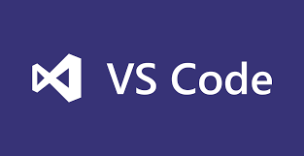    

**Before You Start**

* The directory path shown in screenshots may be different from yours.
* Some steps are not explained in the tutorial**.** If you are not sure what to do:
  1. Consult the resources listed below.
  2. If you cannot solve the problem after a few tries, ask a TA for help.

**Learning Outcomes**

Students will be able to:

* Understand modules in TypeScript.
* Understand asynchronous programming in TypeScript.

**Resources**

* [W3School JavaScript Tutorial](https://www.w3schools.com/js/default.asp)

**Preparation**

1. Open the VS Code and open the **aws-apprenti-2020/CS142/firstnamelastname** directory

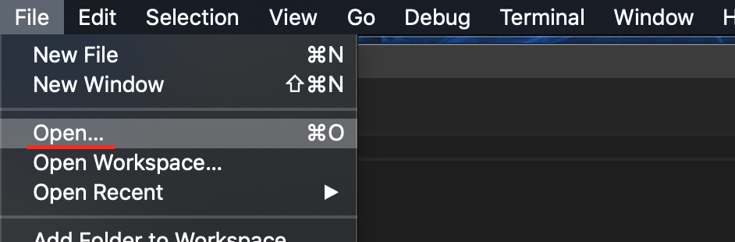

2) Open the terminal from the VSCode, check your current directory using the following command, if you are in **Module 7**, you are in the right place:

**Modules**

1. Create a file called **DoSomething.ts** under the folder and type the following code. 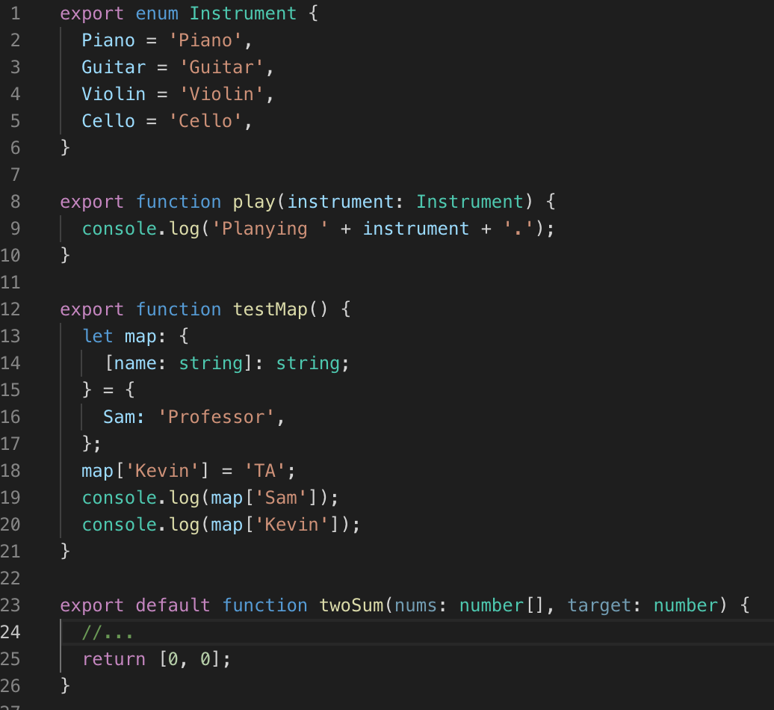

Note: the function twoSum is a solution to the well-known Two-Sum programming problem. Feel free to come up with your own answer to it before continuing.

The Two-Sum Problem:

Input an array of numbers, and the function will return the indices of the two numbers that add up to the target number, assuming there is only one solution. Return [ 0, 0 ] if no answer is found.

For example, with input nums = [3,8,12,2] and target = 11, the function should return [0, 1].

1. Create another file called **Main.ts**.

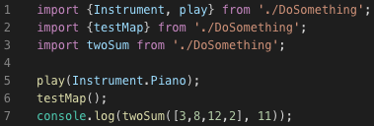

1. Compile the TypeScript file and Run the JavaScript file.

>>> tsc Main.ts

>>> node Main.js

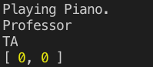

Note: You will get [ 0, 1 ] instead of [ 0, 0 ] if you have created your own twoSum.

1. Add the following function to your **DoSomething.ts** file.

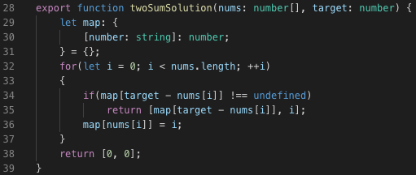

1. Create a **NewMain.ts** file.

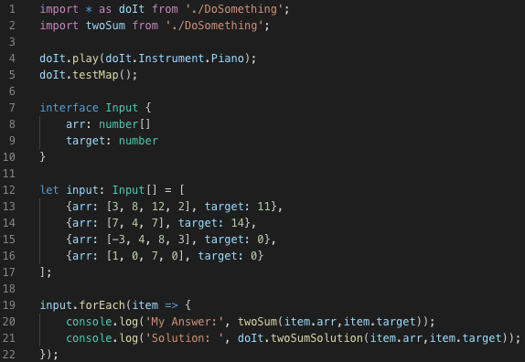

1. Compile the TypeScript file and Run the JavaScript file.

>>> tsc NewMain.ts

>>> node NewMain.js

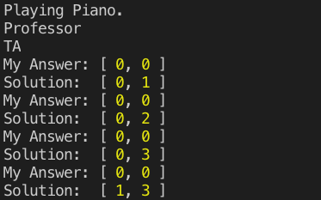

**Asynchronous Programming**

1. Create another file called **SetTimeout.ts**



1. Compile the TypeScript file and Run the JavaScript file.

>>> tsc SetTimeout.ts

>>> node SetTimeout.js



1. Add the following code into the **SetTimeout.ts** file.



1. Compile the TypeScript file and Run the JavaScript file.

>>> tsc SetTimeout.ts & node SetTimeout.js

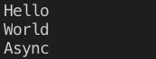

1. Create yet another file called **Promise.ts**.

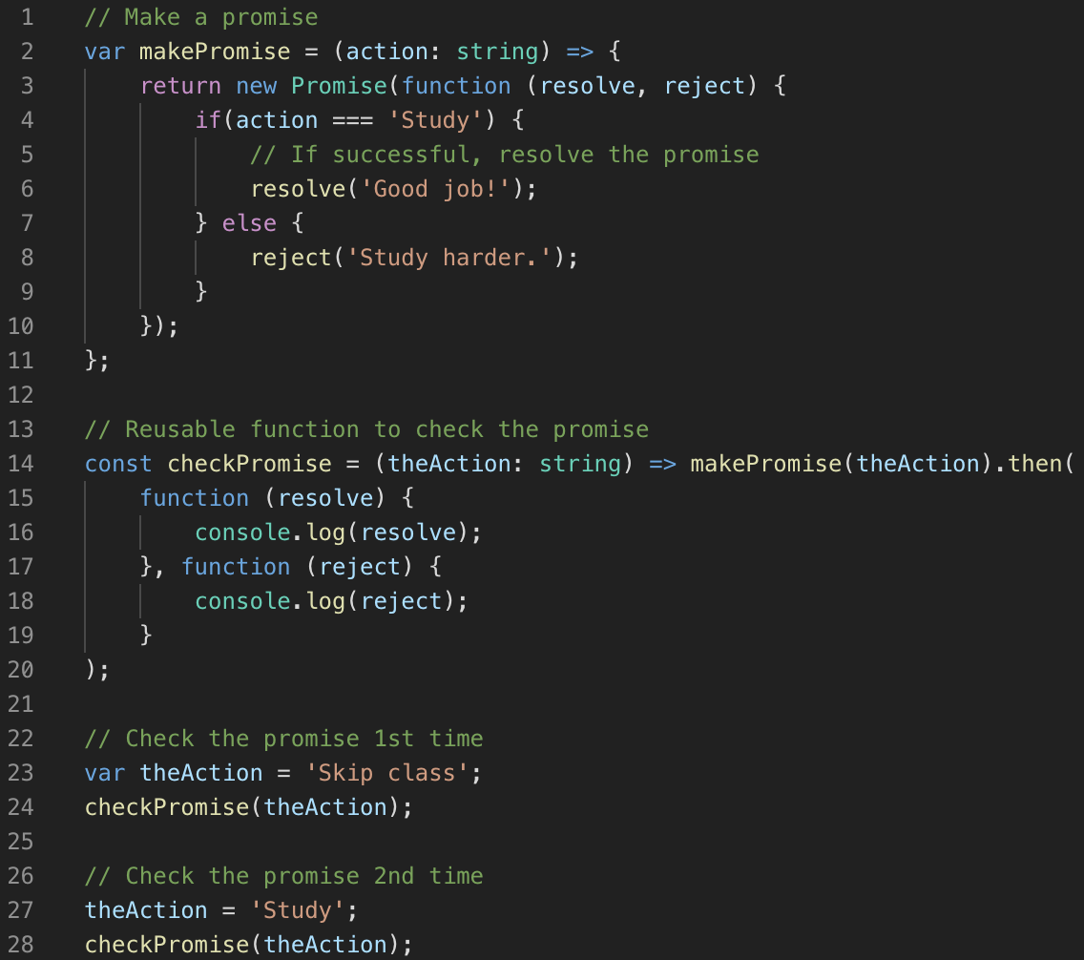

1. Compile the TypeScript file. **You will get an error message.**

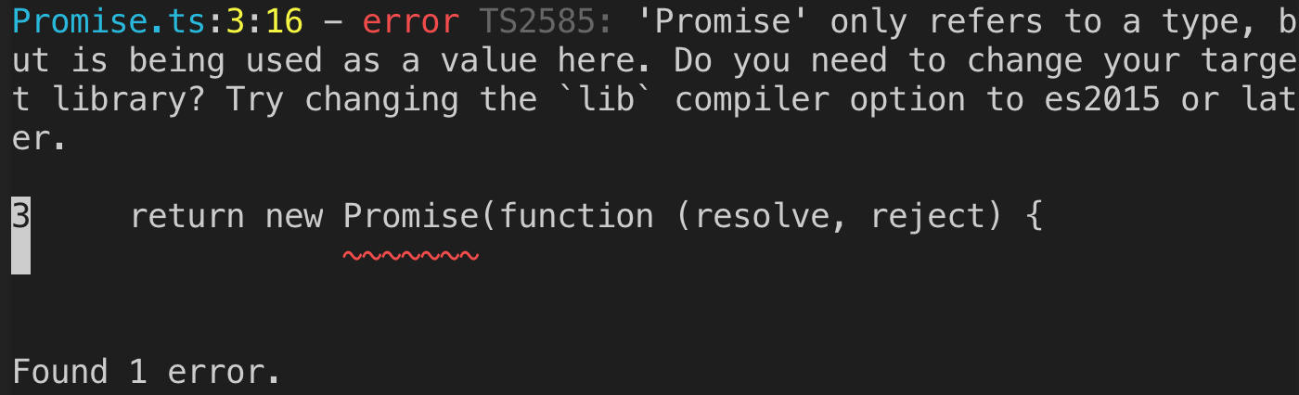

1. Read the error message and try compiling it again with the following command.

>>> tsc --target es2015 Promise.ts

1. Run the JavaScript file.

>>> node Promise.js

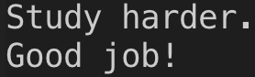

**Push your work to GitHub**

Run the following commands to push your work to the GitHub repository:

Open the terminal from the VSCode by hitting the control + ~ key and type the following command:

**>>> git add .**

**>>> git commit -m “Submission for Module 7– YOUR NAME”**

**>>> git push origin master**